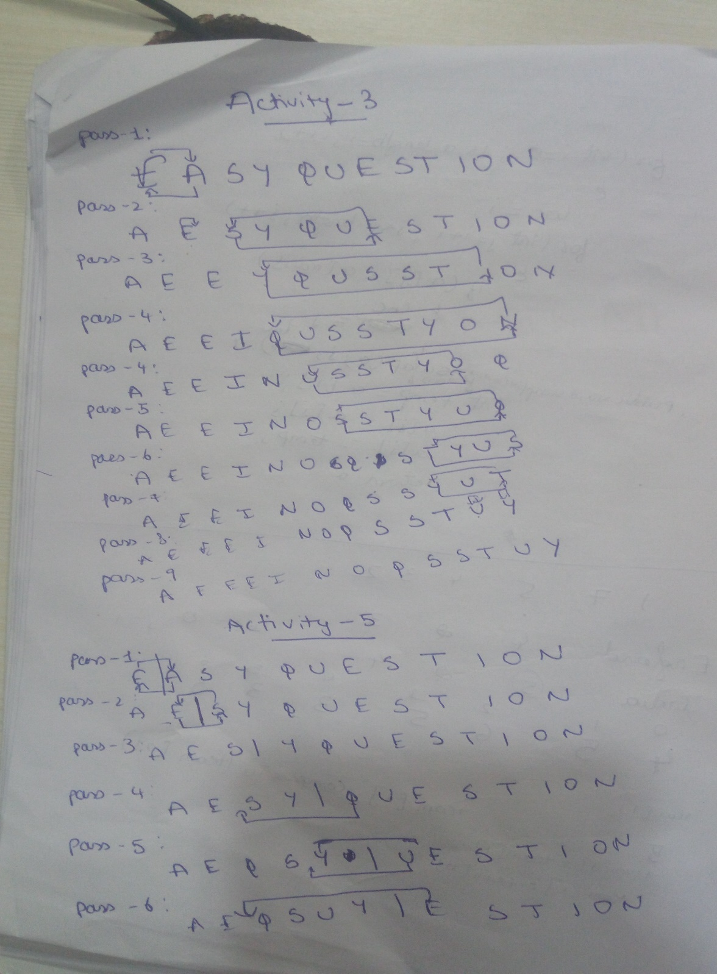

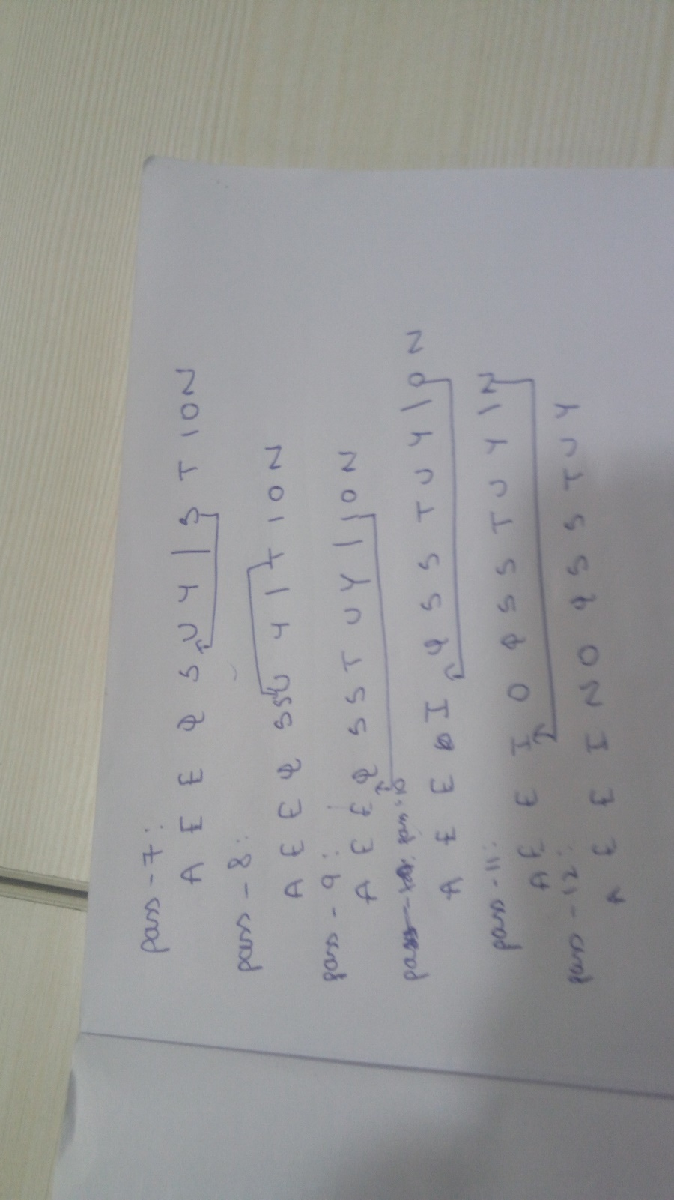

**Activity – 8 :** Insertion sort because it iterates only when condition is satisfied.

**Activity – 9:** Selection sort as for every iteration the list results to be sorted.